Appendix: Sobb & Turnbull, Prioritising Mission Survivability Through Defensive Cyber Operations: A Unified Mission Assurance Approach

Appendix 1. Emergency Management Centre network architecture.
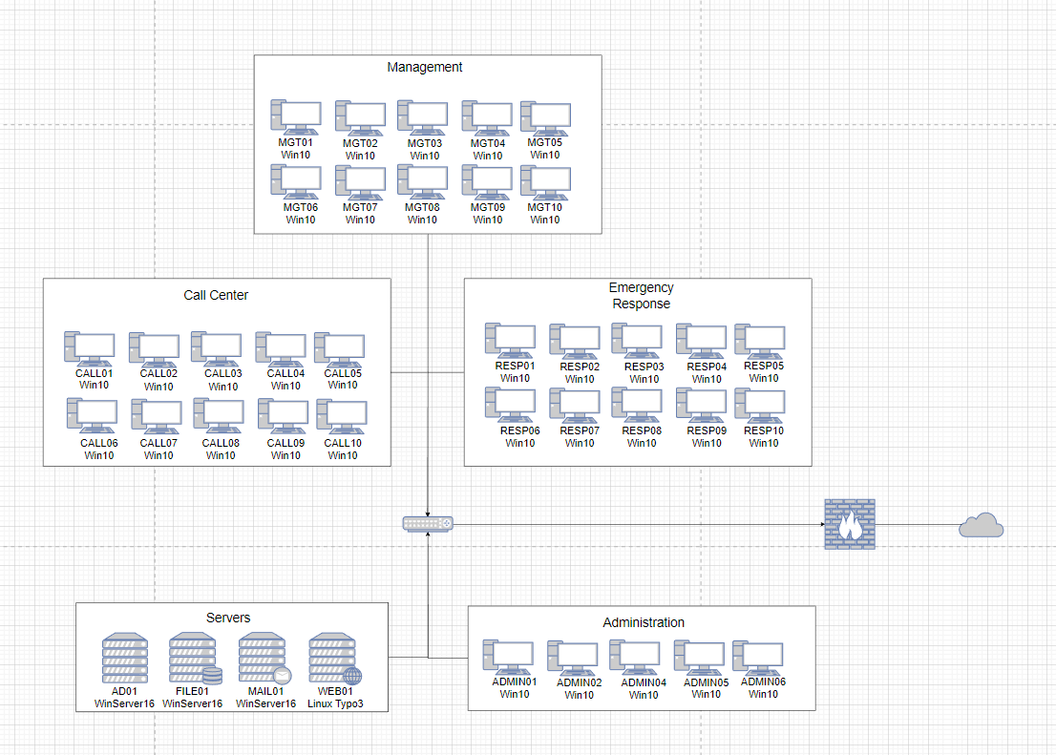

Appendix 2. Excerpt of Exotic Lily, Lazarus Group, APT41 TTP overlay (Htet & Rostovcev, 2019; Taylor, 2022; Htet t al, 2025).
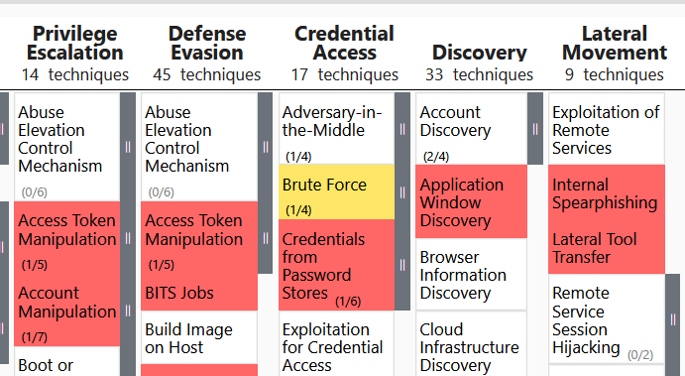
Appendix 3. Most likely threat TTPs (Htet & Rostovcev, 2019; Taylor, 2022; Htet et al, 2025; Millington & Gayda 2025).
MITRE Phase | Most Likely TTP
Reconnaissance | Search victim-owned websites
Initial Access | Valid accounts
Execution | Exploitation for client execution
Persistence | Valid accounts
Privilege Escalation | Valid accounts
Defense Evasion | Valid accounts, Deobfuscate/decode files or information, Impersonation
Credential Access | Brute force
Discovery | File and directory discovery, Network service discovery, query registry, system information discovery, System network configuration discovery, System network connections discovery, System owner/user discovery
Lateral Movement | Internal spear phishing, Lateral tool transfer
Collection | Data from local system
Command and Control | Fallback channels, Ingress tool transfer, Multi-stage channels, Web service
Exfiltration | Exfiltration over C2 Channel
Impact | Data destruction, Data encrypted for impact, Service stop, System shutdown/reboot

Appendix 4. Emergency Management Centre critical infrastructure overlay.
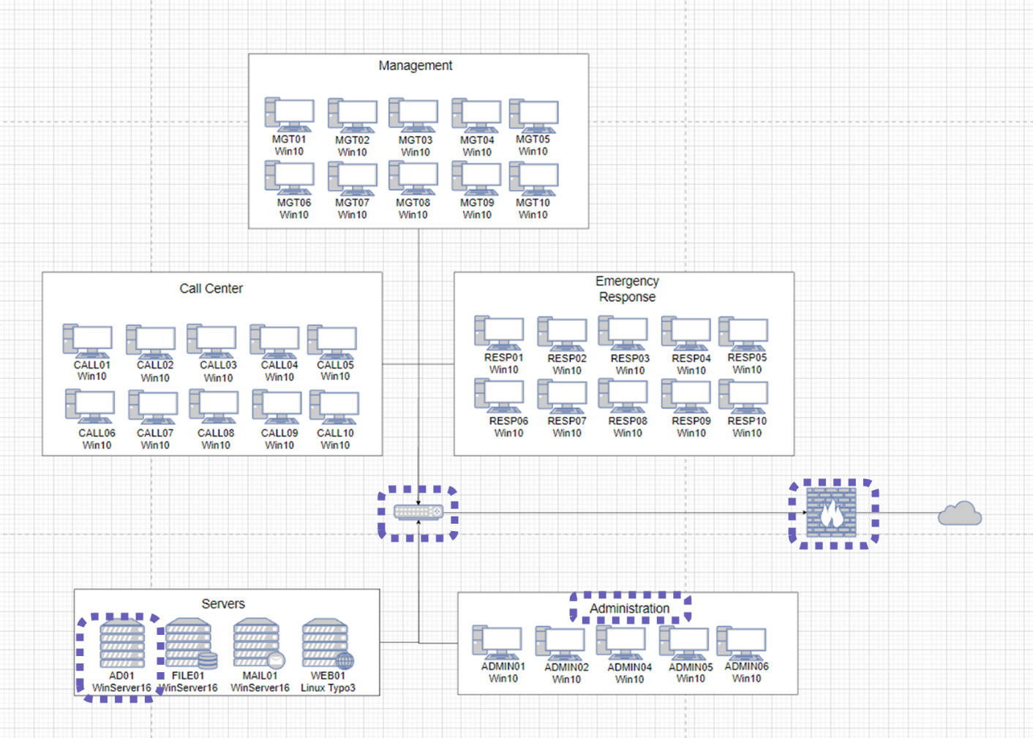

Appendix 5. Outlier registry keys (Haase, 2022).
Host | AD01
Registry | HKCU:\Software\Microsoft\Windows NT\CurrentVersion\Winlogon\
Key | Userinit
Value | userinit.exe, $env:AppData\extheme.exe
Host | RESP10
Registry | HKEY_CURRENT_USER\Software\Microsoft\Windows\CurrentVersion\Run
Key | Blbdigital
Value | rundll32.exe %userprofile%\Ygyhlqt\Bx5jfmo\R43H.dll, Control_RunDLL

Appendix 6. EMC intrusion summary.

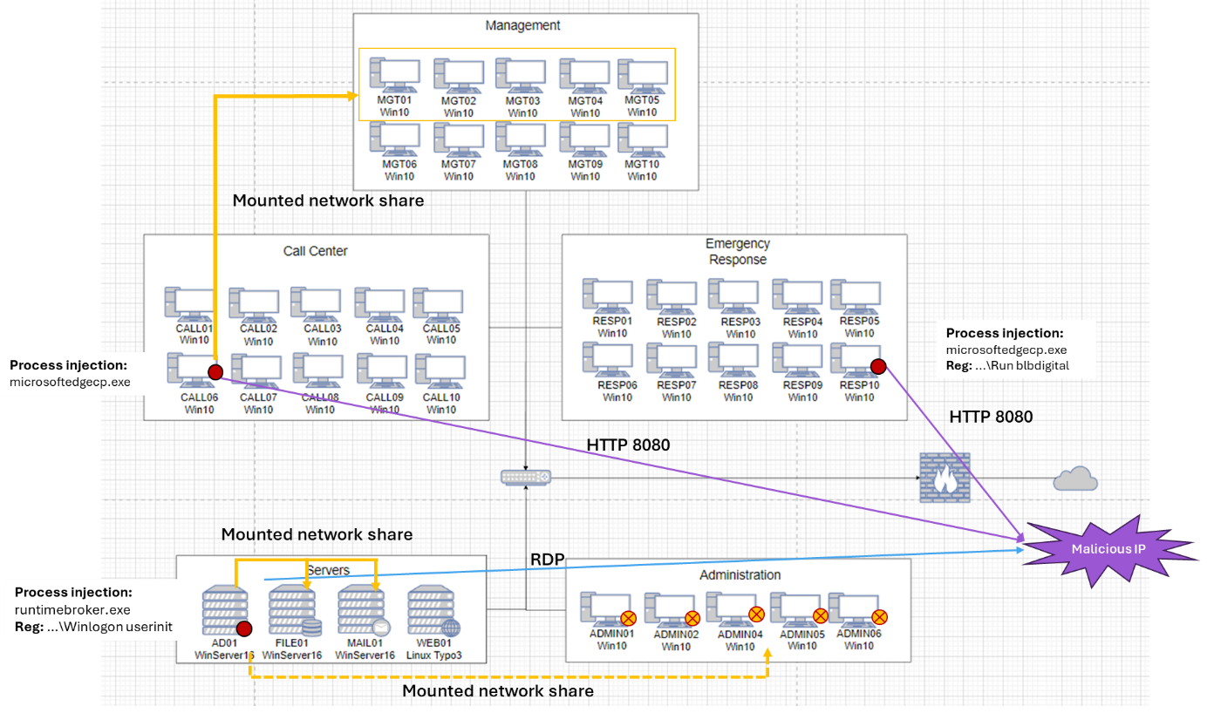

Appendix 7. Technical overview of intrusion flow.

Appendix 8. Observed threat TTP alignment with threat analysis.
MITRE Phase | Observed TTP Alignment with Threat Analysis | Detail
Persistence | Valid accounts | Courtney Stones  John Dorian
Privilege Escalation | Valid accounts | John Dorian
Defense Evasion | Valid accounts | John Dorian
Discovery | System network configuration discovery, System network connections discovery, System owner/user discovery
Lateral Movement | Internal spear phishing, Lateral tool transfer
Collection | Data from local system | Ntds.dit database
Command and Control | Ingress tool transfer | Downloading malicious DLLs, TrickBot, and Ryuk
Exfiltration | Exfiltration over C2 Channel | Ntds.dit database
Impact | Data encrypted for impact, Service stop | Backups stopped  Ransomware

Appendix 9. Infrastructure improvements (Ikpe & Ashigwuike, 2025; Iskandar et al., 2019; Shrimali, 2017; Vitla, 2024).
Observation | Cause | Implication | Proposed Solution | Intended Effect
Visual Basic Script (VBS) downloaded malicious DLL | EMC computers had VBS execution permissions | Potential attack vector for future code download | Domain-wide group policy disabling of Windows Script host in Registry | Stop VBS scripts from running, removing attack vector
New network shares created | All users in domain had new share permissions | Gave adversary ability to move tools across domain | Group policy restriction on creation and modification of network shares, permit only to administrators | Narrows pool of vulnerable accounts which vector can be used
PowerShell used to download malicious DLL and TrickBot malware | All users had PowerShell permissions | PowerShell is a powerful tool that can be used maliciously | Group policy restriction on PowerShell, permit only to administrators | Narrows pool of vulnerable accounts which vector can be used
Public traffic to visit website passing inside domain | EMC webserver was hosted in the Server subnet internal to domain | There is no buffer zone between internal and external traffic, giving external actors internal access | Establish an extra firewall off central router and external firewall. Establish a de-militarised zone (DMZ) for the web server between these firewalls.  Establish rigorous firewall rules on internal firewall | Separation of internet facing servers from internal domain. Restricting visibility and access to internal network.  Reduce pathways for lateral movement
Risk of permanent loss or corruption of critical data | No backup file server or infrastructure | Data loss crippling to EMC essential functions | Implement backup infrastructure such as secondary file server or separate storage solution | Recovery copy of data available in case of primary data loss, reducing service degradation
Legitimate worker remote desktop connections and malicious ones are indistinguishable | 30% of workforce work from home and sign in remotely | Malicious actors can masquerade as remote workers to exploit network | Virtual Private Network (VPN) architecture to be implemented, inclusive of credential logins | Creates a layered security approach.  Differentiates legitimate EMC workers from illegitimate ones

